**Unit-2**

**Chapter-2.5.2**

Mapped with CO-3,4,5

Algorithms for Decision Tree Construction

Decision Tree algorithm belongs to the family of supervised learning algorithms. Unlike other supervised learning algorithms, the decision tree algorithm can be used for solving **regression and classification problems** too.

The goal of using a Decision Tree is to create a training model that can use to predict the class or value of the target variable by **learning simple decision rules** inferred from prior data(training data).**The decision tree algorithm tries to solve the problem, by using tree representation. Each internal node of the tree corresponds to an attribute, and each leaf node corresponds to a class label.**

1.Place the best attribute of the dataset at the **root** of the tree.

2.Split the training set into **subsets**. Subsets should be made in such a way that each subset contains data with the same value for an attribute.

3.Repeat step 1 and step 2 on each subset until you find **leaf nodes** in all the branches of the tree.

•In decision trees, for predicting a class label for a record we start from the **root** of the tree.

•We compare the values of the root attribute with record’s attribute.

•On the basis of comparison, we follow the branch corresponding to that value and jump to the next node.

•We continue comparing our record’s attribute values with other **internal nodes** of the tree until we reach **a leaf node** with predicted class value.

•The modeled decision tree can be used to predict the target class or the value.

**Assumptions**

•Some of the assumptions we make while using Decision tree:

•At the beginning, the whole training set is considered as the **root.**

•Feature values are preferred to be categorical. If the values are continuous then they are discretized prior to building the model.

•Records are **distributed recursively** on the basis of attribute values.

•Order to placing attributes as root or internal node of the tree is done by using some statistical approach

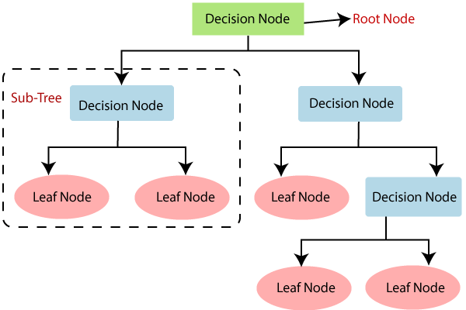

**Book Reading and Video Material**

* Understanding Machine Learning: From Theory to Algorithms by Shai Shalev-Shwartz and Shai Ben-David-Cambridge University Press 2014 [Download](https://www.cse.huji.ac.il/~shais/UnderstandingMachineLearning/understanding-machine-learning-theory-algorithms.pdf) Buy at Amazon
* Introduction to Machine Learning – the Wikipedia guide [Download](http://datascienceassn.org/sites/default/files/Introduction%20to%20Machine%20Learning.pdf)

. <https://www.javatpoint.com/machine-learning-decision-tree-classification-algorithm>

[NPTEL Video](https://youtu.be/7SSAA1CE8Ng)

**Decision Tree.pptx**